Holography and the gauge/gravity duality
MTA Lendület Holographic QFT Group
Wigner Research Centre for Physics

Introduction
The electromagnetic, weak, strong and gravitational forces are the four fundamental interactions of Nature. The first two, unified by the electro-weak quantum gauge theory, have been tested with high accuracy. The strong interaction is formulated also as a gauge theory but its strongly coupled nature circumvented its high precision tests, additionally, the gravitational interaction does not even have a satisfactory quantum formulation.

The gauge/gravity duality gives a hope to understand the strong interaction and quantum gravity in one turn as it connects gauge theories with string theory (including gravity). This duality is a conjecture, which relates strongly coupled gauge theories to semi-classical string theory and the deeply quantum string theory (gravity) to perturbative gauge theory.

The best chance to show the conjectured equivalence of gauge theories and string theory is the 't Hooft limit of the maximally supersymmetric gauge theory as in this limit integrability of the two dimensional string theory shows up.
In the holographic description our 4D Minkowski space, indicated by red on the figure, is the holographic boundary of the 5D anti de Sitter space (blue): AdS. Above each point a 5D sphere is added (green). The fundamental interactions are communicated by open strings ending at matter particles, while gravity is represented by closed strings that can go into the AdS bulk. A graviton absorption by a quark--anti-quark pair is stroboscopically shown. The 2D surface swept by the moving strings is called the worldsheet.

In the last twenty years, motivated by particle physics problems, there have been intensive research and relevant progress in two dimensional integrable theories. These theories were solved in the bulk and also with boundaries by determining exactly the spectrum of particles together with their scattering data which were then used to calculate the full spectrum at any finite size.

The objective of our research is to apply the two dimensional integrable techniques to the holographic duality and as a result to describe strongly coupled gauge theories and investigate the quantum domain of string/gravity theory.

Spectral problem

Heroic efforts have been undertaken in order to test the holographic conjecture. From the many case studies, the following consistent holographic dictionary has been set up:
The energies of string states are related to the anomalous dimensions of local gauge-invariant operators. The 't Hooft coupling of the gauge theory is proportional to the inverse of the string tension, while the number of colors is proportional to the inverse of the string coupling. In the planar (large color) limit, strings do not interact and one has to evaluate the string action on a two-dimensional cylindrically-shaped worldsheet. Due to the high number of symmetries, this effective two-dimensional field theory turned out to be integrable.

Historically, integrability showed up in the weakly-coupled limit of the gauge theory. The anomalous dimension matrix at one loop was mapped to the integrable 1D Heisenberg spin chain, while at higher loops it was related to a long-range spin model. Integrability techniques (such as Bethe Ansatz) were intensively used to determine the spectrum for large sizes (long operators). These results are non-perturbative, i.e. valid for any coupling if the size is sufficiently large, but do not contain vacuum polarization effects. We managed to systematically include such finite-size corrections and determined the anomalous dimensions of short operators at high loop orders.
By summing up all finite-size corrections, an exact description can be found that is valid for any finite size and coupling. This “conceptual” solution of the spectral problem takes the form of infinitely-many coupled (TBA) integral equations. Recently, we managed to rewrite these infinitely-many equations in terms of a finite number of unknowns (NLIE). These results constitute a veritable gold mine, giving an exact interpolating description for all states from weak to strong coupling.

The various methods and their validity ranges are shown on the figure. For weak coupling, perturbative gauge theory is reliable. For large coupling, the string/gravity theory is (semi) classical, allowing a calculational basis. These two validity ranges have no overlap. On the other hand, the holographic correspondence is integrable, thus we can use integrable techniques starting from infinite size and systematically calculate all finite-size corrections. The final solution not only solves the spectral problem, but also gives evidence for the holography: gauge theory and string/gravity theory are two equivalent descriptions of the same phenomena.

Quark anti-quark potential

One of the most important quantities in any gauge theory is the quark--anti-quark potential. It encodes the energy of the configuration in which a particle (quark) and its anti-particle (anti-quark) are separated by a given distance. If the interaction energy increases linearly with the distance, then the quark and anti-quark pair cannot be separated: the theory is confining, like QCD. If the interaction energy decreases with the distance, then we can observe free quarks. After almost half a century of intensive study, the confinement problem of QCD still remains a mystery. Due to the strongly coupled nature of the gauge theory, there is no analytical method to calculate the potential exactly, and we have to rely on numerical simulations such as lattice QCD. Holography can change this status completely. By holography, we can map the strongly-coupled gauge theory to semi-classical string theory, over which we have good analytical control.

The quark--anti-quark potential in the holographic picture. The potential energy of the configuration in the gauge theory is related to the string/gravitational partition function of the 2D surface. For large coupling it is simply the minimal area, while for finite coupling we have to include the quantum fluctuations as well.

The maximally supersymmetric gauge theory is scale invariant, which forces the quark--anti-quark potential to be proportional to the inverse of the distance, as in quantum electrodynamics. So this theory is not confining; nevertheless, the coefficient (strength) of the potential depends nontrivially on the gauge coupling. Standard perturbative calculations determine this coefficient in terms of a power series giving a good approximation for small coupling. For large coupling, the holographic description can be used to calculate the string/gravitational partition function on the surface spanning the worldlines of the quark and anti-quark. At leading order, it amounts to evaluating the area of the minimal surface, while for finite coupling the quantum fluctuations must all be included, which is taken into account by a boundary thermodynamic Bethe Ansatz equation. We proposed a novel formulation of the BTBA equations, based on real chemical potentials and additional source terms, which allows a systematic weak coupling expansion. We expanded our equations to second (double wrapping) order and tested the results against direct two-loop gauge theory computations. We find complete agreement [1].

Tachyons in AdS/CFT: brane anti-brane system

In most of the applications of the duality we gain information on the strongly coupled gauge theory from the weakly coupled string theory/gravity. Duality, however, allows us to learn about quantum string theory or quantum gravity in a highly curved background. Especially, we can study tachyons in string theory, which are non-perturbative objects signalling instabilities: A brane--anti-brane system is an unstable open string system and it is believed that the branes annihilate with each other and decay into closed strings, however, there are no non-perturbative results supporting this idea in the literature for curved backgrounds.
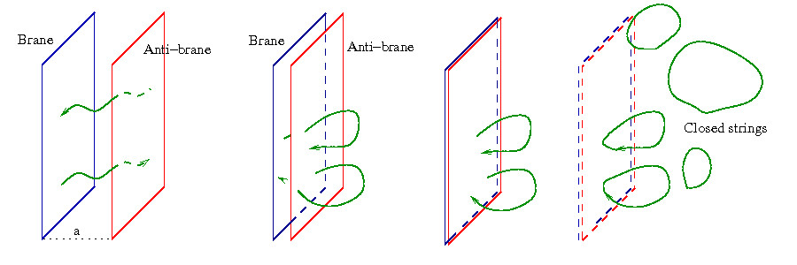

Our experience with integrable boundaries together with our insight into the gauge/string duality allowed us to study this relevant problem. We developed a complete description of the brane--anti-brane system both on the gauge theory and on the integrable model sides [2].

In particular, we analyzed the spectrum of open strings stretched between a D-brane and an anti-D-brane in planar AdS/CFT using various tools: spin-chain, boundary asymptotic Bethe ansatz and boundary thermodynamic Bethe ansatz (BTBA).

We found agreement between a perturbative high order diagrammatic calculation in N = 4 SYM and the leading finite-size boundary Lüscher correction. We studied the ground state energy of the system at finite coupling by deriving and numerically solving a set of BTBA equations. While the numerics give reasonable results at small coupling, they break down at finite coupling when the total energy of the string gets close to zero, possibly indicating that the state turns tachyonic. The location of the breakdown is also predicted analytically.
[1] Zoltán Bajnok, János Balog, Diego Correa, Árpad Hegedűs, Fidel I. Schaposnik Massolo and Gábor Zsolt Tóth, Reformulating the TBA equations for the quark anti-quark potential and their two loop expansion, e-Print: arXiv:1312.4258.
[2] Zoltán Bajnok, Nadav Drukker, Árpád Hegedűs, Rafael Nepomechie, László Palla, Christoph Sieg and Ryo Suzuki, The spectrum of tachyons in AdS/CFT, e-Print: arXiv:1312.3900.

